Miniscope DAQ PCB Fabrication Information

* 4 layers: Suggested spacing is in ‘USB_Control_BoardStack.xls.’ I am not concerned with the spacing between layers other than to maintain 90ohm impedance on 3 differential pairs discussed below.
* Order of copper layers:
  + Component layer (Top Layer)
  + Ground plane (GP1)
  + Power plane (GP2)
  + Signal layer (Bottom Layer)
* Board Dimensions 3.1 in X  2.25 in
  + Board outline in ‘USB_Control.GM2’
* Finished Thickness 0.062 inches (I am flexible on this)
* FR4
* Minimum Spacing: 6mil
* Minimum Trace: 5mil
* Minimum Hole Size: 7mil
* Surface finish: ENIG
* Solder Mask Color: Green
* Silk Screen Color: White
* Inner Copper: 1 oz Inners
* Outer Layer Finish Copper: 1 Oz
* Screen Sides: Top and bottom
* Tented Vias
* Controlled impedance for 3 high/super speed USB differential pairs shown below (10% tolerance)

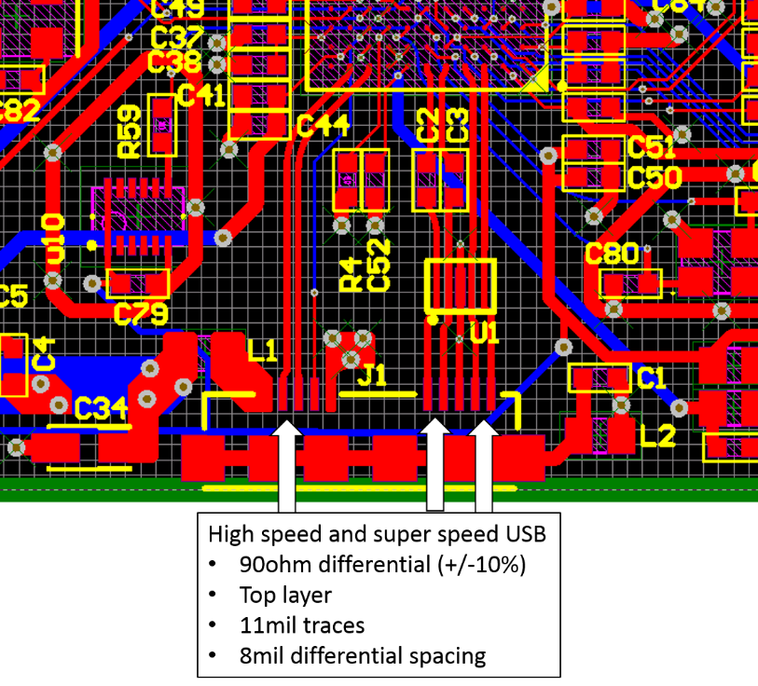

|  |  |
| --- | --- |
| Top Layer |  |
| GP1  (inverted) |  |
| GP2  (inverted) |  |
| Bottom Layer |  |